**ABHIJIT DASH**

**RA1811031010112**

**PREDICTIVE PARSING TABLE**

**AIM:-**

To compute predictive parsing table for the given grammar.

**CODE:-**

#include<bits/stdc++.h>

using namespace std;

int main()

{

char fin[10][20], st[10][20], ft[20][20], fol[20][20];

int a, i, t, b, n, j, s = 0, p; cout<<"Enter the number of productions: ";

cin>>n;

cout<<"Enter the productions of the grammar:\n"; for(i = 0; i < n; i++)

cin>>st[i];

cout<<"\nEnter the FIRST and FOLLOW of each non-terminal:";

for(i = 0; i < n; i++)

{

cout<<"\nFIRST["<<st[i][0]<<"] : ";

cin>>ft[i]; cout<<"FOLLOW["<<st[i][0]<<"] : ";

cin>>fol[i];

}

cout<<"\nThe contents of the predictive parser table are:\n";

for(i = 0; i < n; i++)

{

j = 3;

while(st[i][j] != '\0')

{

if(st[i][j-1] == '|'|| j == 3)

{

for(p = 0; p <= 2; p++) fin[s][p] = st[i][p];

t = j;

for(p=3; st[i][j]!='|' && st[i][j]!='\0'; p++, j++) fin[s][p] = st[i][j];

fin[s][p] = '\0';

if(st[i][t] == 'e')

{

a = b = 0;

while(st[a++][0] != st[i][0]);

while(fol[a][b] != '\0')

{

cout<<"M["<<st[i][0]<<","<<fol[a][b]

<<"] = "<<fin[s]<<"\n"; b++;

}

}

else if(!(st[i][t] > 64 && st[i][t] < 91))

cout<<"M["<<st[i][0]<<","<<st[i][t]

<<"] = "<<fin[s]<<"\n";

else

{

a = b = 0;

while(st[a++][0] != st[i][3]);

while(ft[a][b] != '\0')

{

cout<<"M["<<st[i][0]<<","<<ft[a][b]

<<"] = "<<fin[s]<<"\n"; b++;

}

}

s++;

}

if(st[i][j] == '|') j++;

}

}

return 0;

}

**OUTPUT SCREENSHOT:-**

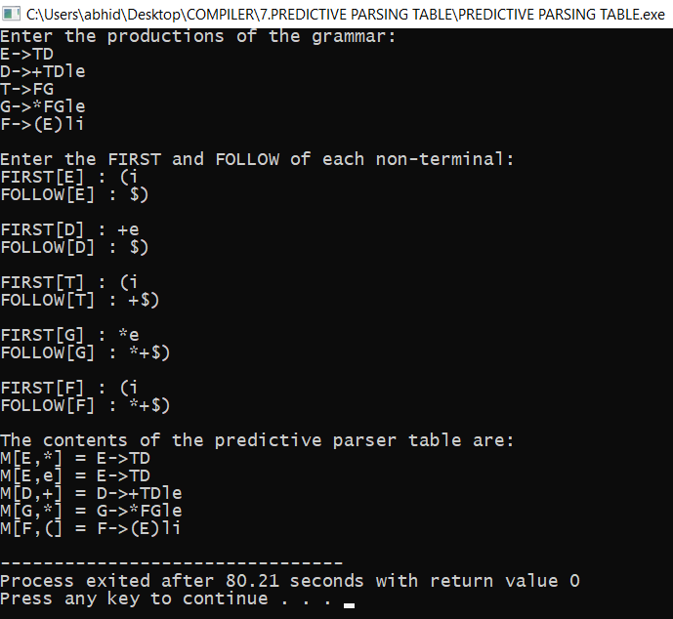

**RESULT:-**

The output was generated successfully for the given production of a grammar.